**Lab 9: Measuring electrical signals with the oscilloscope**

650:361 Introduction to Mechatronics

Team Members: Shivani Topiwala, Nancy Contreras, and Pamela Pajarillo

**Task 1: Low Pass Filter**

|  |  |  |  |  |
| --- | --- | --- | --- | --- |
|  | Magnitude in [Ω] | | Phase in [deg] | |
|  | Measured | Nominal | Measured | Nominal |
| R | 995.6 Ω | 1 kΩ | 0 | 0 |
| Xc | -150.91 Ω | 159.15 Ω | 270 | 270 |
| Z | 1.01 kΩ | 1.15915 kΩ | 351.38 | 350.9587 |

Table 1: Impedances with Measurement Frequency of 1000 Hz

|  |  |  |  |  |  |
| --- | --- | --- | --- | --- | --- |
|  | Frequencies | | | | |
|  | 100 Hz | 300 Hz | 500 Hz | 1250 Hz | 1500 Hz |
| Magnitude | 1.72 kΩ | 1.11 kΩ | 1.04 kΩ | 1.00 kΩ | 1.00 kΩ |
| Phase | 306.49 | 334.31 | 343.52 | 353.08 | 354.23 |

Table 2: Equivalent Impedance with Different Measurement Frequencies

|  |  |
| --- | --- |
|  | Measurements |
| Magnitude | 1.43 kΩ |
| Frequency | 140 Hz (Calculated: 159 Hz) |

Table 3: Frequency at which phase angle is 315 deg

**Task 2: No Task 2**

**Task 3: Bode Plot**

A bode plot is a graph that can represent the gain and phase of a system as a function of frequency. These plots exist in what is referred to as the frequency domain. They are displayed in a logarithmic scale in order to observe the change clearly since the range of frequency is very large with comparatively small magnitude and phase angle changes.

$f{}_{co}$ = 144.54 Hz

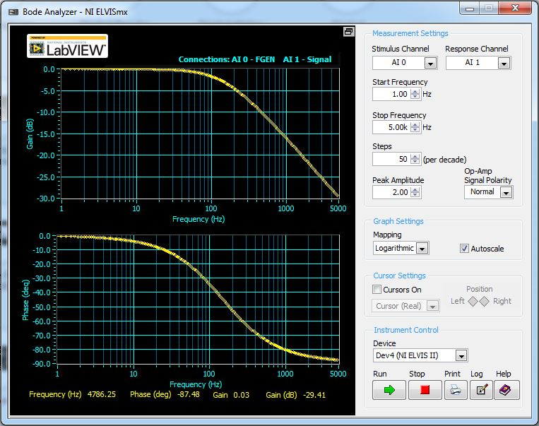

**Task 4: LED Diode Circuit**

We will build the given LED-diode circuit on the NI Elvis II Workstation. We used Variable Power Source in order to measure the DC Offset point of the diode by manually changing the voltage. Offset voltage is a limit where the light gets off.

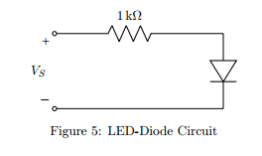

$V{}_{off}$ = 1.55 V

**Conclusion**

In this lab, we analyzed a low pass filter using the NI Elvis II. Using the corresponding software, we were able to measure and calculate the resistance, the reactance, and impedance for each circuit. We also compared our results to the frequency response of a simple RC circuit. We found that as frequency increases, the phase increases and the magnitude decreases.

We also were introduced to the concept of a bode plot. We used the bode plot in order to analyze the frequency response of the given system.